**Name : Shashank K**

**ID : SE21UCSE198**

**Lab Submission 5**

I have chosen the fractional knapsack problem and implemented the function **“knapsack”** in python.

**Overview:**

I have given three inputs as dictionaries. The structure of dictionary follows {value:weight}. The function accepts a dictionary and a weight value as parameters.

The function first sorts the dictionary based on the ratio value:weight in descending order. It then starts choosing the values with highest ratios.

The complexity of **sorted** in python is O(nlogn). The complexity of the traversal of dictionary is n at max so the max complexity would be O(nlogn) if we consider the sorting complexity too. The space complexity is O(n).

**Inputs :**

example1 = {50:10,60:20,80:30}

W1 = 40

example2 = {10: 2,5: 3,15: 5,7: 7,6: 1}

W2 = 10

example3 = {100: 20,60: 10,120: 40,50: 30}

W3 = 50

**Output:**

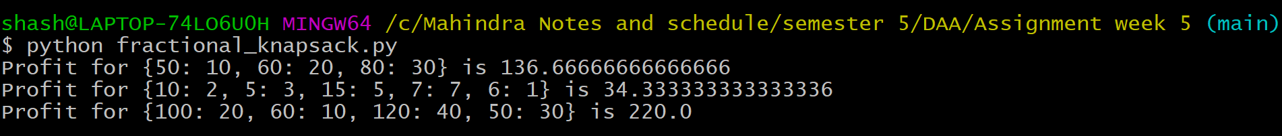

**Cross check on paper**

